Sales Configurator Set up and Report Generation.

Pre-Requisites
-MS Visual Studio 6.0(for Sales Configurator 8.2.0)
-MS Visual Studio .NET(for Sales Configurator 8.3.0)
-IFS Extended Server Administrator.
-Configured Part Data including a configuration family in the centura client. (The customer should be allowed to export to the sales configurator. This could be done by ticking the Sales Configurator check box.
-MS Front Page or any other html editor to create reports, orders and proposals.

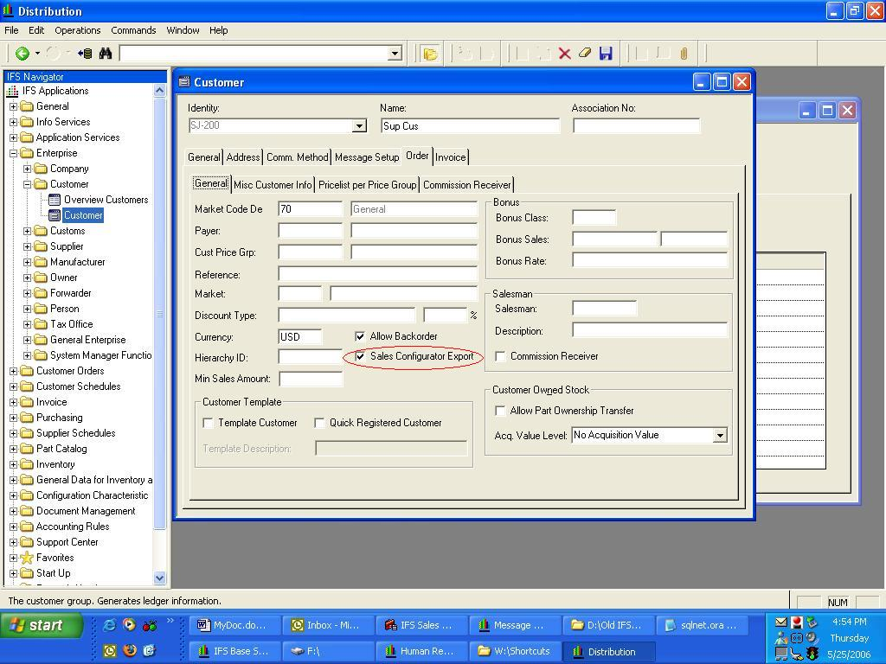

Note: - Your user should be granted with the SCONF_WORKSHOP role from the admin tool.

Installation

Install the Sales Configurator by running theWokhshopSetup.exe in \\Cmbdb8\GSE_49\files\Build_Patch\SCONF. You may have to give the appowner when installing the workshop. Then install the Sales Configurator by running the SalesConfiguratorSetup.exe in the same location.

Note: - To install version 8.3.0 for APP7, run the msi files in the following links.
- Sales Configurator - \\cmbfs3\Application Releases\Archive7\sconf\core\sconf 8.3.0\sconf\win32client\IFS Sales Configurator\Execute
- Sales Configurator Work Shop - \\cmbfs3\Application Releases\Archive7\sconf\core\sconf 8.3.0\sconf\win32client\IFS Sales Configurator Workshop\Execute

Go to Control Panel/Administrative Tools/Data Sources/ to set up an oracle data source.
Select the System DSN tab.

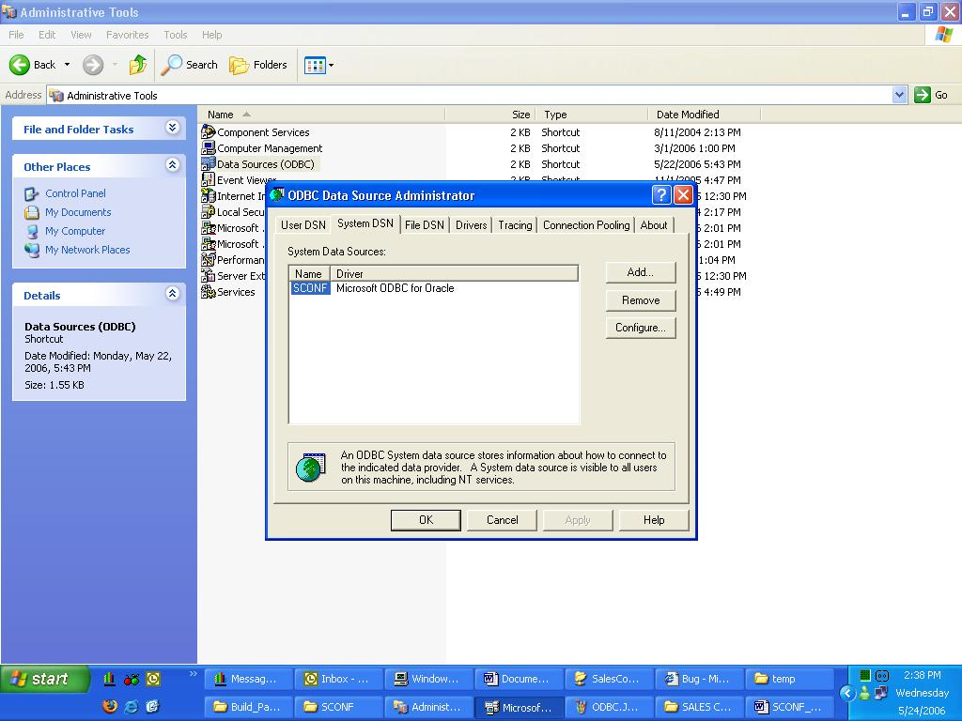

Press the Add button to select an ODBC data source. Select the Microsoft ODBC for Oracle option.

Note: - In the case of Sales Configurator 8.3.0 the oracle ODBC drivers should be used instead of the MS ODBC drivers. If these drivers cannot be found in the Data Source Window they have to be installed using the Oracle Universal Installer.

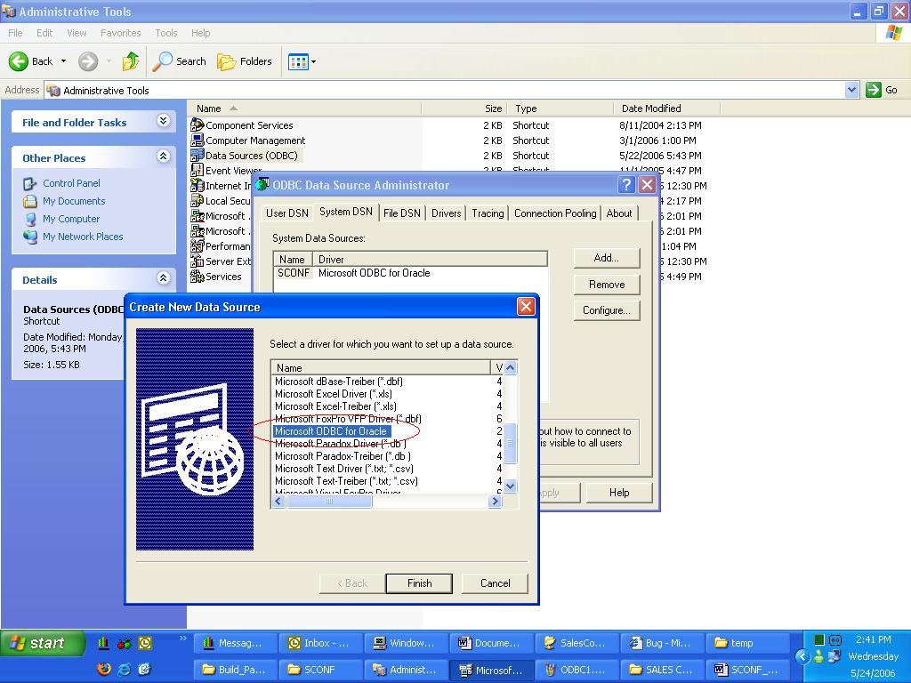

Then enter data source name, description and the server you want to connect.

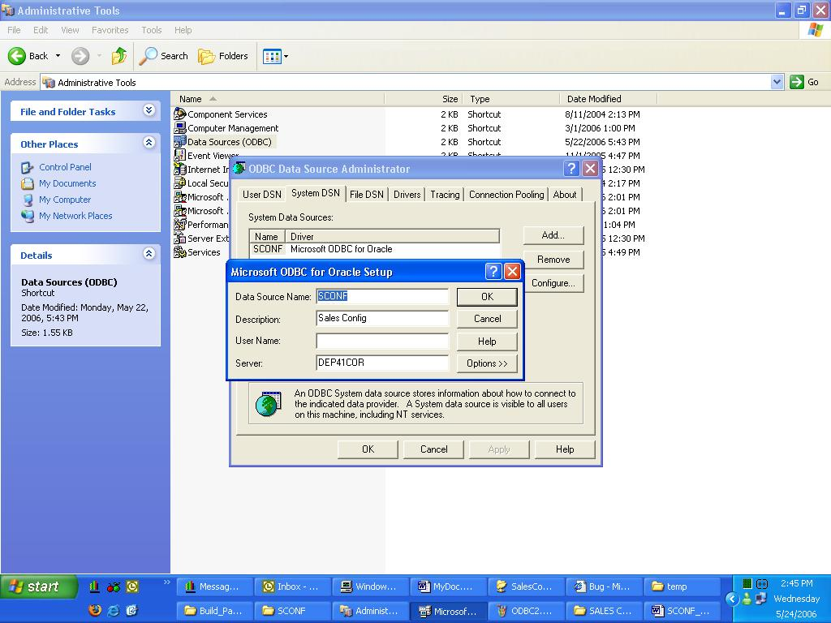
The Data source name will appear in the data bases field when you execute the sales Configurator.

You can use the user “SalesRep” or “default” to log into the Sales Configurator.

You have to select the customer from contacts/select contact to get the customer in to the order header.

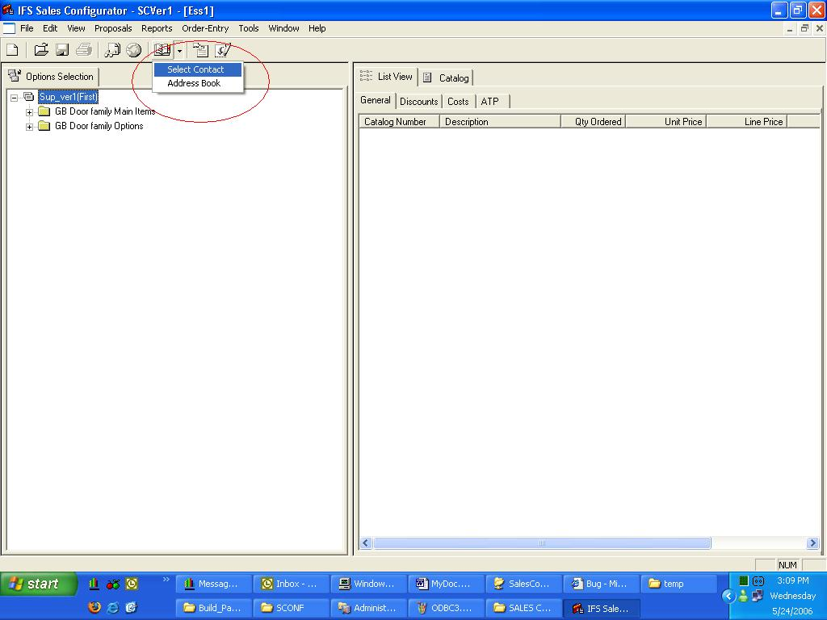

In order to send the configuration to incoming COs we have to set up routings from IFS Extended Server Administrator.

Setting Up Routing Rules using Extended Server Administrator

These set-up configurations are for the Dep2004-1 environment.

Login to Configurator
User name: SalesRep or Default
Password:
These users can be added by WorkShop client.

Settings of Configurator
Sender: SCONF
Receiver: CONNECT
Address: http://cmbdbapp09.asia.corpnet.ifsworld.com:63080/ifs/webservices

Extended Server Set-up
Login to “IFS Extended Server Administrator” client.

User: ifsapp
Connect to: cmbdbapp09:63080

In Basic Data/Users, check the following, which is used to transfer data to the base server.
User ID: SYSTEM
Directory ID: IFSAPPSYS

Go to: Connect Administration/Message Routing/Destination Address
Add a new destination address with the following settings.

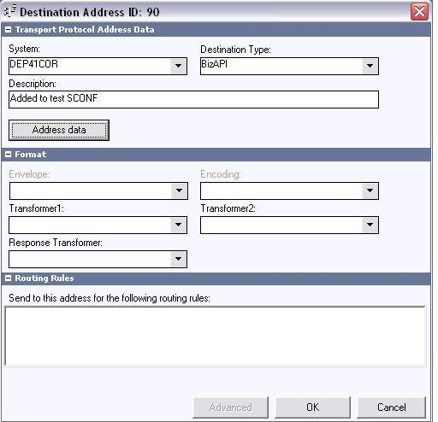

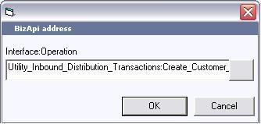

Go to Inbound Routing tab and create a new routing rule as follow.

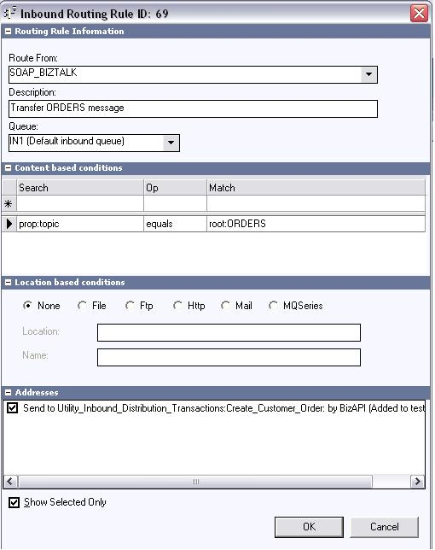
Now transfer the configuration from the Sales Configurator and check whether it has been accepted by the extended server.
Check it in Connect Administration/Message Queues/Default inbound queue (IN1)
If there is no any problem, the message state should be in finished.
Check the SOAP message as well.

Check the Base Server
Login to the Base Server Administration tool.
Go to Foundation1 Administration/Connectivity/In Message Box.
Query by Sender: SCONF.
The state should be in “Accepted”.

Then you can check it in the Incoming Customer Orders of the IFS application. Query it by the Message Id.

Creating Reports

In order to create reports we should define a page using the page define window in the Design tab. In the design tab we should enter a design layout.

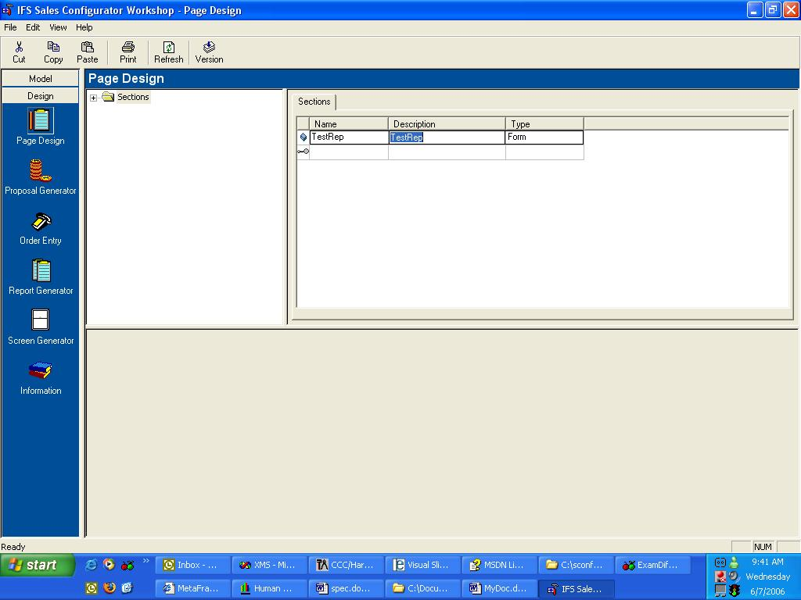

Then select the entered layout from the navigator and go to the attributes tab. Click the browse button and the Pds Folder within the IFS Sales Configurator will open. You can create a new file or you can select an existing html file to create your page design.

Note:- The page design files should be created only within the Pds Folder.

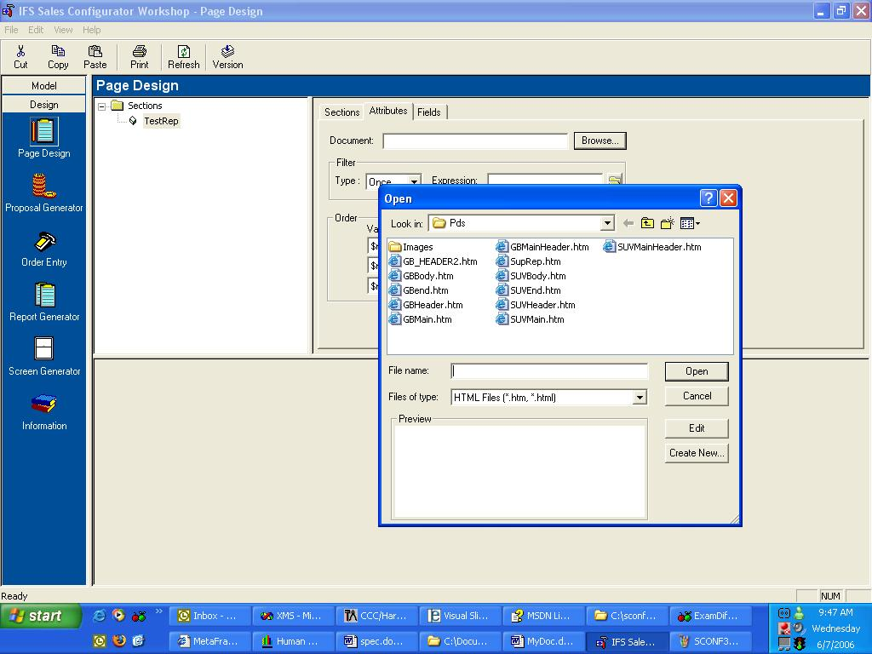

Then select the existing HTML file or the newly created file from the browse window and click the edit button. This will open your default HTML Editor. You can edit the page as you want from that.

In order to embed field names within the report you have to follow a special nomenclature. Fieldname should be given like [#<fieldname>].
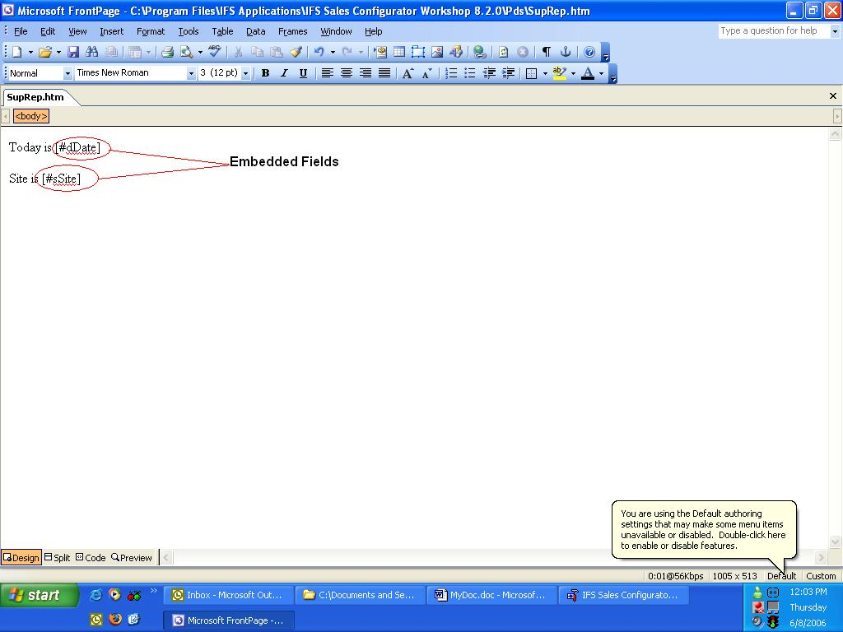

The above report will look like below when we see this from the Sales Configurator Client.

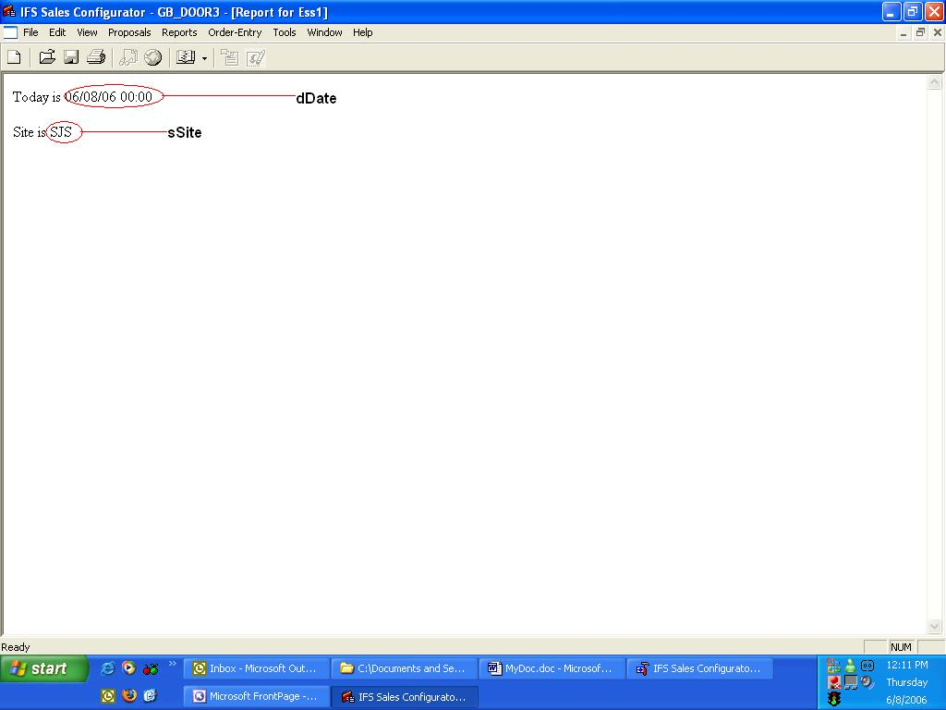
In Order to map what is in the page design to the report, we have to enter a record in the Report Generator window. Then go to the rules tab and enter a rule. Some useful rules can be found in the tasks window under the Model category. The name column should be filled with the name of the designPage Record we entered earlier. This can be selected as shown below.

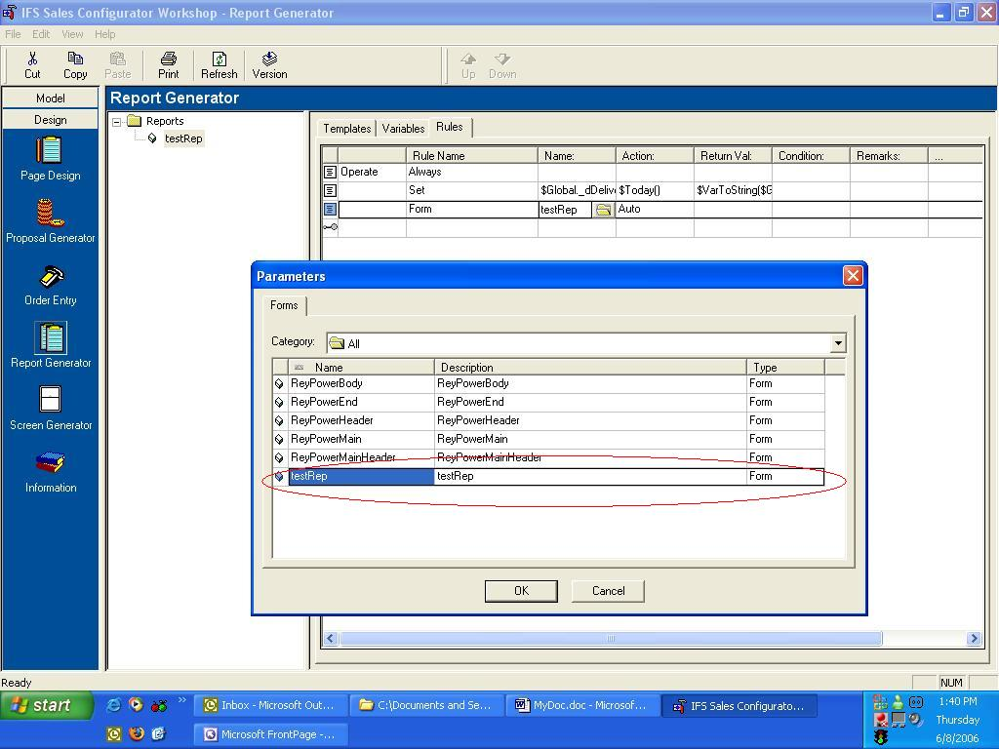

You can select the value for the return column by clicking the parameter button on the dialog box you get after clicking on the open folder icon in the Return Val column.

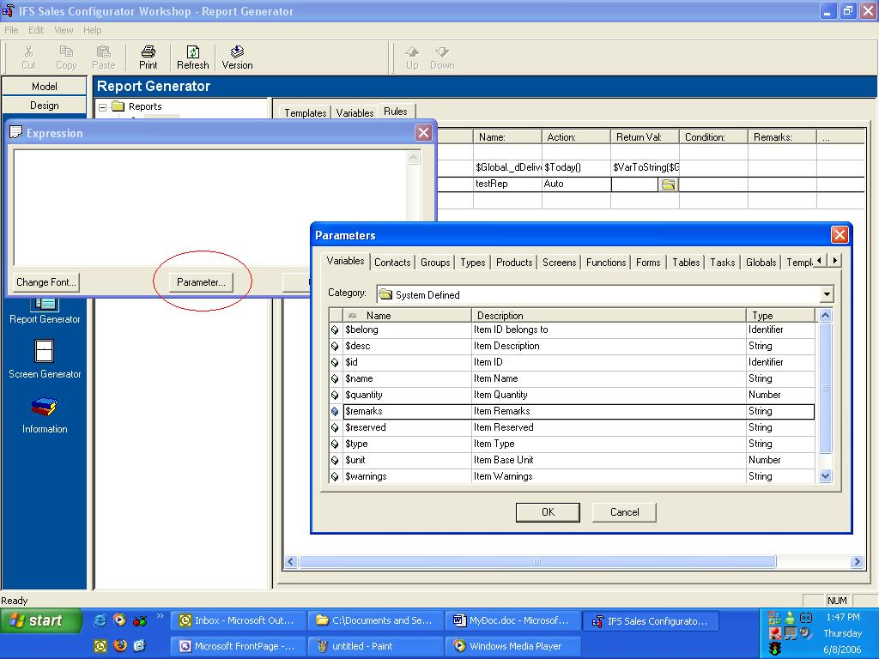

Then save the version and open the Sales Configurator Client. You can view the reports you have created in the work shop from by clicking the reports option in the menu.

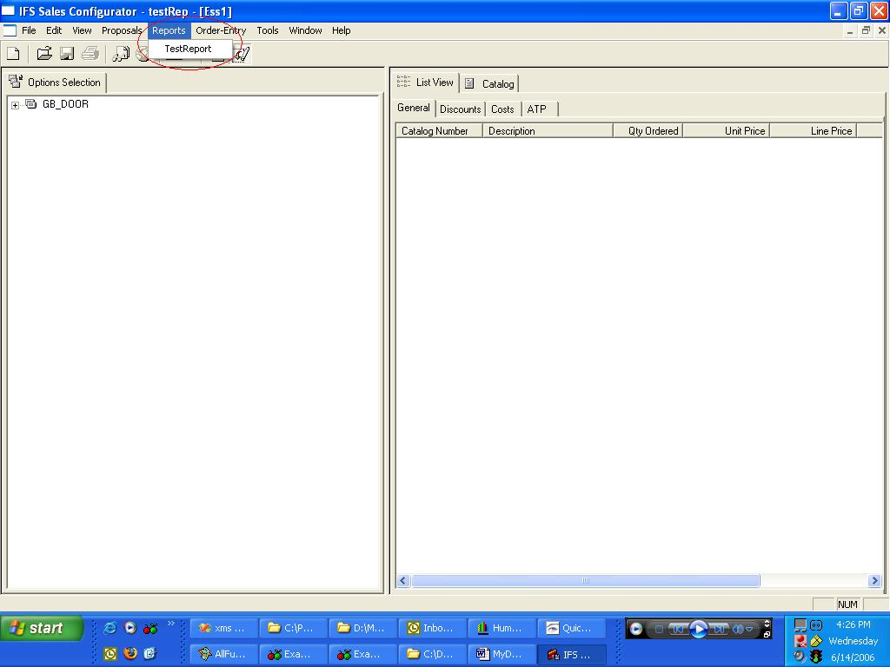

Then save the version and go to the Sales Configurator client. In the reports menu you will get the name of the report you saved from the workshop.

